STMP Manufacturing Application
StMfgTool User’s Manual

Copyright © 2008 Freescale Semiconductor, Inc. All rights reserved.
The following are trademarks or service marks of Freescale Semiconductor, Inc., and may be used to identify Freescale Semiconductor products or services only: Freescale Semiconductor, the Freescale Semiconductor Logo, C-Major, D-Major and GoChip. Other products, services and company names contained herein may be trademarks or service marks of their respective owners.
Manufacturing Application License Agreement
IMPORTANT--READ THESE TERMS CAREFULLY AND MAKE SURE THAT YOU UNDERSTAND THEM BEFORE USING THIS SOFTWARE; DO NOT USE THIS SOFTWARE IF YOU DO NOT AGREE TO THE FOLLOWING TERMS: This Manufacturing Application License Agreement ("Agreement") is a legal agreement between you (either an individual or a single entity) and Freescale Semiconductor, Inc. (Freescale Semiconductor), for the Manufacturing Application Software which may include associated software components, software licensed by Freescale Semiconductor from third parties (Licensors), media, printed materials, and "online" or electronic documentation ("Software Product"). By installing, copying, or otherwise using the Software Product, you agree to be bound by the terms of this Agreement. The Software Product is protected by copyright laws and international copyright treaties, as well as other intellectual property laws and treaties.
1. GRANT OF LICENSE. Freescale Semiconductor grants you the right to install and use the Software Product on your computers running validly licensed copies of the operating system for which the Software Product was designed [e.g., Windows 2000®, Windows® XP, etc.]. You may also make copies of the Software Product as may be necessary for backup and archival purposes.
2. PROHIBITIONS AND RESTRICTIONS. You must not remove or alter any copyright notices on all copies of the Software Product. You may not distribute copies of the Software Product to third parties, other than your manufacturing contractors who have agreed to maintain the Software Product in strict confidence. You may not rent, lease, or lend the Software Product. You may not reverse-compile, disassemble, reverse-engineer, or use any other method to convert the Software Product into a human-readable form, nor may you allow another person to do so. The Software Product may not be duplicated, corrected, modified, or disposed of in any other way in part or in whole. The creation of derivative works based on the content of the Software Product is also prohibited. You may not export or import the Software Product in violation of United States or foreign government export control laws and regulations.
3. COPYRIGHT. All title, including but not limited to copyrights, in and to the Software Product and any copies thereof are owned by Freescale Semiconductor or its Licensors. All title and intellectual property rights in and to the content which may be accessed through use of the Software Product is the property of the respective owner and may be protected by applicable copyright or other intellectual property laws and treaties. This Agreement grants you no rights to use such content. All rights not expressly granted are reserved by Freescale Semiconductor.
4. NO WARRANTIES AND LIMITATION OF LIABILITY. The Software Product and any related documentation were developed at, and are copyrighted by, Freescale Semiconductor and/or its Licensors. The Software Product is offered "AS IS" and neither Freescale Semiconductor nor its Licensors make any warranty, or grant any indemnity, with respect to its use or performance. THE ENTIRE RISK ARISING OUT OF USE OR PERFORMANCE OF THE SOFTWARE PRODUCT REMAINS WITH YOU. FREESCALE SEMICONDUCTOR AND ITS LICENSORS DO NOT AND CANNOT WARRANT THE PERFORMANCE OR RESULTS YOU MAY OBTAIN BY USING THE SOFTWARE OR DOCUMENTATION. NEITHER FREESCALE SEMICONDUCTOR NOR ITS LICENSORS MAKE ANY WARRANTIES, EXPRESS OR IMPLIED, AS TO NON-INFRINGEMENT OF THIRD PARTY RIGHTS, MERCHANTABILITY, OR FITNESS FOR ANY PARTICULAR PURPOSE. IN NO EVENT WILL FREESCALE SEMICONDUCTOR OR ITS SUPPLIERS BE LIABLE TO YOU FOR ANY CONSEQUENTIAL, INCIDENTAL OR SPECIAL DAMAGES, INCLUDING ANY LOST PROFITS OR SAVINGS, OR LOSS OF DATA, EVEN IF A FREESCALE SEMICONDUCTOR REPRESENTATIVE HAS BEEN ADVISED OF THE POSSIBILITY OF SUCH DAMAGES, OR FOR ANY CLAIM BY ANY THIRD PARTY.
5. GENERAL. If any provision of this Agreement is held unenforceable, that provision shall be enforced to the maximum extent permissible so as to give effect the intent of this Agreement, and the remainder of this Agreement shall continue in full force and effect. This Agreement shall be governed by the laws of the United States and the State of Texas, without reference to conflict of laws provisions thereof, and without regard to the United Nations Convention on Contracts for the International Sales of Goods.
Table of Contents

1. Scope 5

2. Introduction 5

3. system requirements 5

4. installation and Setup 5
4.1. Installing the Manufacturing Application 5
4.2. Static-ID Firmware 5
4.3. Physical Setup 6

5. APPLICATION OVERVIEW 7
4.4. The Player Profile 7
4.5. Player Operations 8
4.6. The Operations Panels 8
4.7. USB Ports 9
4.8. The Status Information Panel 9
4.9. The Start/Stop Button 9

5. Configuring the Application 10
5.1. Profiles (tab) 11
5.1.1. Profile/Operation Configuration Status 11
5.1.2. New/Save (button) 12
5.1.3. Delete (button) 12
5.1.4. Profile (drop-down list) 12
5.1.5. USB Vendor ID 12
5.1.6. USB Product ID 12
5.1.7. SCSI Vendor ID 12
5.1.8. SCSI Product ID 12
5.1.9. Volume Label 12
5.1.10. Operations (list) 13
5.1.10.1. Operation 13
5.1.10.2. Folder 13
5.1.10.3. Files 13
5.1.10.4. Options 13
5.1.11. Operations (menu) 13
5.1.11.1. Enable 13
5.1.11.2. New 13
5.1.11.3. Edit 13
5.1.11.4. Delete 13
5.1.11.5. Move up 13
5.1.11.6. Move down 14
5.1.12. Operation Editors (dialogs) 14
5.1.12.1. Update Operation 14
5.1.12.1.1 Step 1 – Name the operation 14
5.1.12.1.2 Step 2 – Define the drive allocation table and firmware files 15
5.1.12.1.3 Step 3 – Specify the update boot firmware 16
5.1.12.1.4 Step 4 – Select update options 16
5.1.12.2. COPY Operation 16
5.1.12.2.1 Step 1 – Name the operation 17
5.1.12.2.2 Step 2 – Select files for the operation 17
5.1.12.2.3 Step 3 – Select options for the operation 17
5.1.12.3. LOAD Operation 18
5.1.12.3.1 Step 1 - Name the operation 18
5.1.12.3.2 Step 2 – Specify the custom firmware application 18
5.1.12.3.3 Step 3 - Specify options for the operation 18
5.1.12.4. OTP Operation 19
5.1.12.4.1 Step 1 – Name the operation 19
5.1.12.4.2 Step 2 – Enter the value to be written 19
5.2. USB Ports (tab) 19
5.3. General (tab) 20
5.3.1. Options 21
5.3.2. AutoPlay 22

6. Initializing the system 22
6.1. Step 1 - Pre-Loading the Recovery Mode Driver (STMP 35/36XX) 22
6.2. Step 2 - Pre-Loading the Static-ID USB Mass Storage Driver 22
6.3. Step 3 - Reboot the System 23

7. Running the Application 24

8. Registry Scrub 24
8.1. Profile Description (drop-down list) 25
8.2. Clean (button) 25
8.3. Close (button) 25
8.4. Remove Static-ID Entries (checkbox) 25

9. APPENDIX 26
9.1. Troubleshooting 26
9.2. Error Codes 28

Scope

This document explains how to use Freescale Semiconductor’s STMP Manufacturing Application (StMfgTool). It is intended for Freescale Semiconductor customers, or their OEMs, who plan to mass manufacture STMP based solutions.

Introduction

The STMP Manufacturing Application is designed to expedite flashing of firmware and copying of files into STMP based hardware. Manufacturing enhancements over the end-user application, StUpdaterApp.exe, include:
- Parallelism – up to 16 devices can be updated concurrently. More concurrent updates may require additional computing resources such as processor speed and memory.
- Continuous operation – operations automatically begin with the arrival of a new device, and multiple operations such as Update and Copy can be linked together seamlessly.
- Enumeration – static-id firmware loaded into RAM in recovery-mode prevents Windows® from enumerating every device.
- AutoPlay - various Windows® ‘pop-up’ application and status messages, such as Explorer in Windows® XP, and “Unsafe hardware removal” in Windows® 2000, are suppressed.
- Registry – in addition to minimizing Windows® registry entries, an integrated utility is provided to keep the registry in good operating order.

The STMP Manufacturing Application is designed to flash firmware onto NAND devices and pre-load the data area with media files in an efficient and convenient manner. The application is NOT designed to test the devices or to diagnose manufacturing problems. Devices initialized with this application still need to be functionally verified.

In order to maximize manufacturing efficiency, please read this entire document and follow the procedures as outlined. The setup and configuration for this application is extensive and must be followed in order to provide the speed enhancements and operator ease outlined above.

system requirements

Minimum PC Requirements – 2.0 GHz CPU, 1GB RAM

Windows® 2000 w/Service Pack 4, or Windows® XP w/Service Pack 2

Either separate internal USB 2.0 controllers or external USB 2.0 powered(2.5 A) hubs.

installation and Setup

Installing the Manufacturing Application
There is no installation application for the StMfgTool application. Simply create a folder where the application will reside and copy it there. The included example profiles may be copied to a Profiles folder under the folder where the StMfgTool application is copied.
A shortcut may be created to launch the application from a desktop icon, or the start menu.

Static-ID Firmware
Static-ID Firmware reduces manufacturing time significantly by eliminating the unique enumeration of every device. Therefore, it is strongly recommended that this option be used. The static-ID firmware option is enabled by default for UPDATE operations and must be unchecked in the operations editor to disable it.
If Static-ID Firmware will be used, the firmware image file must be created and pre-loaded. SDK versions 2.600 and later do not require a patch to the firmware, however the document StMfgTool Static-ID Firmware Application Note included with the SDK 2.251 firmware patch explains in detail how to build and where to place the static-ID firmware.

Physical Setup
Connect the devices according to one of the diagrams below. Figure 1 represents the USB hub based physical setup configuration.
PC
STMP Device
STMP
Device

Internal USB 2.0
Port
External USB 2.0 Hub with a 2.5A power-supply

STMP
Device

STMP
Device

Figure 1

Connect an external USB 2.0 powered(2.5 A) hub to the PC’s USB connection. The PC should recognize the external USB hub. The USB ports(up to 16) on the external hub(s) will be configured for use by the Manufacturing Application (see Section 5.2). Please note that the hub needs to be USB 2.0 compliant and also needs to be externally powered with a 2.5 A power supply, and not bus powered.

Figure 2 represents the direct connect setup configuration. Each device connects to a single port on an internal PCI USB controller. This configuration is limited to the number of PCI slots available. It is important that there is a single device connected per USB controller.

PC
PCI USB 2.0 Controller
STMP
Device

PCI USB 2.0 Controller
STMP
Device

PCI USB 2.0 Controller
STMP
Device

Figure 2

5. APPLICATION OVERVIEW

This section introduces the application’s main window, describes the function of the various elements, and defines terms necessary to describe the overall program operation. The main application window’s un-initialized state is shown here in Figure 3, and the main window’s running state is shown at the end of this section in Figure .

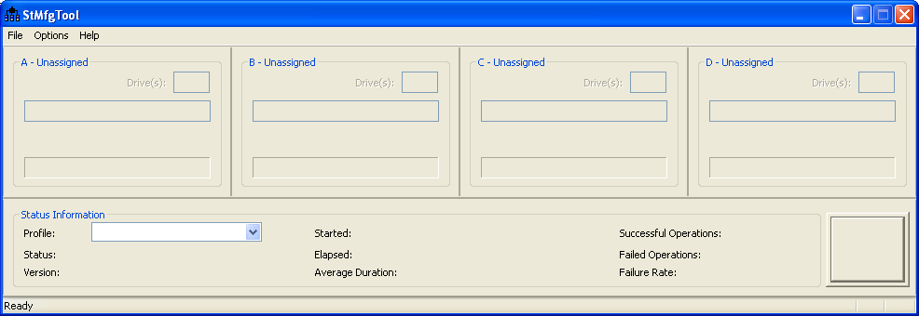
Operation
Panels
A-D
Profile Selection and Status
Menu Items
USB Port
Assignment

Start/Stop Button
Figure 3

The Player Profile
StMfgTool centers around Player Profiles. A Player Profile (profile) is a directory and file structure containing all the information about a particular product, the name of the product, USB IDs, SCSI IDs, device firmware files, and media files. The profile also contains a list of one or more Player Operations (operations) to be performed on devices matching the profile.
The Profile control of the Status Information area window displays the currently selected profile (see Figure ). Use this control to switch between profiles.
Creating and editing profiles is explained in Section 5, under the main heading, Configuring the Application.
The Start/Stop button in the Status Information Panel will not be enabled unless a valid profile is selected.

Player Operations
Each Player Profile has a list of one or more Player Operations (operations) that are to be performed on the device matching the profile. Currently there are four types of operations supported by StMfgTool, OTP, UPDATE, COPY, and LOAD. Instructions regarding the creation, editing and enabling of operations begins in Section 5.0 under the main heading, Configuring the Application.
Enabled operations begin executing after the Start button in the main application window has been pressed. If a profile lists multiple operations, the enabled operations will be run consecutively, one after the other. The status of the operations is displayed in its Operations Panel.
Once all of the operations for a particular device are complete, the user simply needs to remove the device from the USB port, and replace it with the next device. The operations will automatically begin on the new device.
Operations are executed on a port-by-port basis. The operations on one USB port are independent of the operations on another USB port.

The Operations Panels
The main application window contains multiple Operations Panels. The number of panels is configurable in the USB port configuration, and may be 4, 8, 12, or 16. Each panel is labeled A, B, C, and up to P. Each panel is assigned a physical USB port through the USB port configuration dialog (see Section 5.2, USB Ports (tab)). The assigned USB hub and port are shown for each panel (see Figure ), and unassigned panels display Unassigned (see Figure 3).
Monitoring - Once a USB port is assigned to a panel, USB device activity on the assigned port is monitored in the corresponding Operations Panel. An Operations Panel is in monitoring mode when a port has been assigned to the panel, and the Start button has not been pressed. The Operation field in the panel (see Figure ) will display Monitoring… when in this mode.
In monitoring mode, the panel will display the name of the device connected to its assigned port in the Status Box (see Figure ). If a device is not connected to the assigned port, No device connected is displayed. Any drive letters associated with the connected USB device will be displayed in the panel’s Drive Letter Box.
Running – After the Start button has been pressed, the Operations Panels reflect the operating or running state of the application (see Figure ). The Operation field in the panel will display the type of the current operation when in running mode.
As in monitoring mode, the Operations Panel’s display is directly tied to its assigned USB Port. Any drive letters associated with the connected USB device will be displayed in the panel’s Drive Letter Box. The Status Box shows status information about the current operation and the profile’s list of operations as a whole. Operations Complete is displayed when all of the operations in the profile’s list have been completed for a device.
The Progress Bar indicates progress through the list of operations (see 4). The Progress Bar grows to the right and is BLUE while processing operations. When all operations for a device have been completed, the Progress Bar is completely filled and turns GREEN. A RED Progress Bar indicates an operation failure.
Device Completion – A device is complete when all operations have finished successfully. Device completion is shown in the Operations Panel with Operations Complete in the status box, and a completely filled GREEN progress bar.
Error Condition – An error condition exists when the Operations Panel displays a RED progress bar. The status box will contain an error message describing the problem, or an error code found in Appendix 9.

USB Ports
A physical USB port is assigned to an Operations Panel during the application configuration process detailed in Section 5.2, USB Ports (tab). The assigned USB hub and port are shown for each Operations Panel (see Figure 4), and unassigned panels display Unassigned (see Figure 3).
The Start button in the Status Information Panel will not be enabled unless at least one USB Port is assigned an Operations Panel.

The Status Information Panel
The Status Panel is located near the bottom of the main application window. Profile selection is made here from any profiles under the Profiles folder. The status of the profile and firmware version of any UPDATE operation is also listed.
Once the Start/Stop button is pressed and the operations begin, status information on the operations is displayed including:
Start Time - Time the operations began
Elapsed Time - How long have operations been running
Average Duration - Average time to complete a single device
Successful Operations - How many devices successfully updated
Failed Operations - How many device updates have failed
Failure Rate - Percentage of failures

The Start/Stop Button
The Start/Stop button is adjacent to the Status Panel. The Start/Stop button will not be enabled unless a valid profile and USB ports are selected.
The Start/Stop button is a three state button. The background color and text describe the action when pressed.
When a valid profile and USB ports are selected the operations are ready, and the button displays a green background with the word “Start”. Pressing Start causes the Operations Panels to switch from monitoring mode to running mode.
In running mode the background color is changed to red and the text to “Stop” as the application iterates through the profile’s list of operations on a port-by-port basis. The progress of the operations is reflected in the Operations Panel associated with its specific USB port.
As finished devices are replaced with new devices, the operation loop begins again automatically.
To stop the operation loop, and return the Operations Panels return to monitoring mode, click on Stop. The button background color changes to yellow and the text to “Stopping…”. This allows the processing operations to reach a stable stopping state.
Once the Operation Panels return to monitoring mode after pressing Stop, the button returns to the green Start button
There are three conditions that must be satisfied before the Start button is enabled:
- A valid Player Profile must be selected (Section 5.1).
- The Player Profile must contain at least 1 enabled operation ( Section 5.1.10).
- At least 1 USB port must be assigned to an Operations Panel ( Section 5.2).
Additionally, the application must be in monitoring mode before any of the following actions can be initiated:
- Changing the configuration.
- Running the Registry Cleaning utility.
- Closing the application.
Figure 4 below shows an example run of four devices with one in a completed state, another in an error state, and two others still processing operations.
USB Port
Assignment
Driver Letter Box

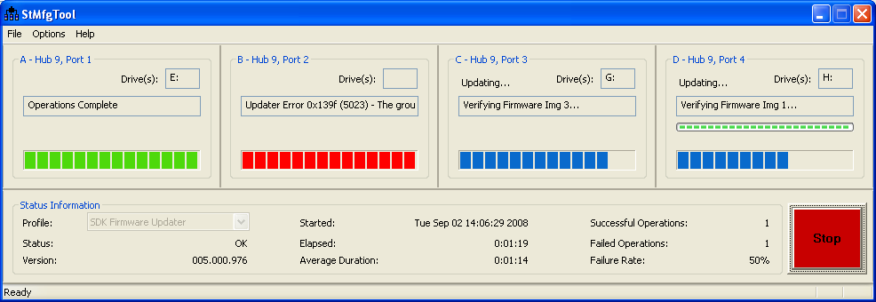
Figure 4

Configuring the Application

The Manufacturing Application’s settings must be configured before the application can be used. The sections below explain how to configure these settings. To configure the settings, on the main application window, select menu item Options→Configuration. In the Configuration window, there are three tabs: the Profiles (tab), the USB Ports (tab), and the General (tab) .

After the settings for the profiles are configured correctly, select OK at the bottom of the Configuration window to save the settings. Configured settings are saved and will be used upon subsequent executions of the manufacturing application. No changes are made until the user selects OK.

To abandon all changes select Cancel at the bottom of the Configuration window.

Profiles (tab)
The Profiles tab (See Figure .) allows the user to set up and select an individual manufacturing profile. A manufacturing profile contains all the information about the intended hardware target including various identifiers, a list of operations to be performed, and any support files an operation may require.
Note: Multiple example profiles are provided containing firmware supporting the STMP device families.

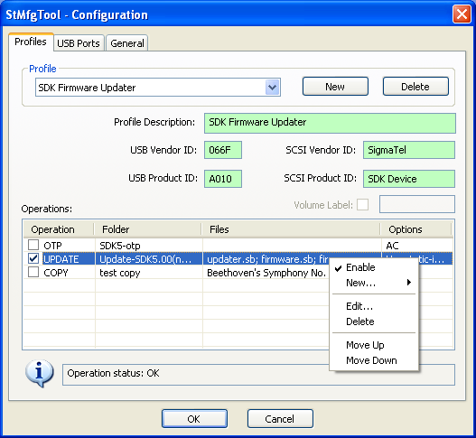
Figure 5

Profile/Operation Configuration Status

The status pane at the bottom of the Profile configuration window (see Figure 5) is used to display information about the profile configuration.

Profile status: is the configuration status of the profile as a whole and is displayed any time an operation is not highlighted in the Operations list.

Operation status: is the configuration status of a selected operation.

Profile status: OK - All the profile parameters and operations are set correctly.

Profile warning: - All the profile parameters are correct, there is at least 1 valid operation, and there are invalid operation(s) in the Operations list. The invalid operation will be denoted by a ‘!’ in the operation checkbox. Highlighting the operation will provide information about the operation’s error. Invalid operations will not be executed.

Profile error: - Profile parameters are incorrect, or there are no valid operations.

This state will prevent the Start button in the main application window from being enabled.

Operation status: OK – All the operation parameters are set correctly. Operation may be enabled or disabled.

Operation error: - There is a problem with the operation. The operation will have a ‘!’ in the operation checkbox. The operation can not be enabled, and will not be executed.

New/Save (button)

Create a profile by clicking the New button in the Profile group box found in the top, right-hand corner of the Profiles tab in the Configuration dialog. Clicking the New button clears any existing profile data in the controls and the New button text changes to Save. To save new profile data, you must click Save.

Delete (button)

Deletes the currently selected profile. This operation will delete all directories and files associated with the selected profile and its operations.

Profile (drop-down list)

Profile name describing the product to be operated on. The application supports multiple profiles, but only the current selected profile in the Status Panel will be used for operations.

USB Vendor ID

The 4-digit hexadecimal value representing the USBMSC VID of the device. This value must match the corresponding ID reported by the usbmsc firmware.

USB Product ID

The 4-digit hexadecimal value representing the USBMSC PID of the device. This value must match the corresponding ID reported by the usbmsc firmware.

SCSI Vendor ID

The 8-character (max.) string representing the SCSI VID of the device. This value must match the corresponding ID reported by the usbmsc firmware.

SCSI Product ID

The 16-character (max.) string representing the SCSI PID of the device. This value must match the corresponding ID reported by the usbmsc firmware.

Volume Label

This field contains the text that will be used by update and format operations to label the volume. The field is limited to 11 characters and must conform to Windows® file-naming conventions. The Volume Label field will not be used unless it is checked.

Operations (list)

Lists the operations set up for the given profile. Operations are executed in order from top to bottom. Only operations that are enabled (checked) will be executed.

Operation
The operation type and a checkbox to enable or disable the operation. An operation can be enabled or disabled at any time by clicking the checkbox associated with the operation. The operation type can only be modified in the Operation Editor dialog.

Folder
The name of the operation. This field is used as a folder name under the profile folder and contains any files required by the operation. The operation folder must conform to Windows® file-naming conventions, and can only be modified in the Operation Editor dialog.

Files
A list of the files required by the operation. The operation files can only be modified in the Operation Editor dialog.

Options
A list of the enabled options for the operation. The operation options can only be modified in the Operation Editor dialog.

Operations (menu)

Actions available for the operations list through the right-click context menu (see Figure 5).

Enable
Enables or disables the operation. Only enabled operations will be executed. Disabling an operation does not delete the folder and files associated with the operation. This action can also be performed by clicking on the checkbox associated with the operation, or by pressing the keyboard space bar with the operation highlighted.

New
Adds an additional menu for the selecting operation type. Selecting the new operation type brings up Operation Editor dialog for that particular operation type.

Edit
Brings up the Operation Editor dialog box and initializes it with the values from the selected operation.

Delete
Removes the operation from the operations list and deletes all folders and files associated with the operation. This action may also be performed by pressing the delete-key while an operation is highlighted.

Move up
Moves the selected operation up in the operations list. Since operations are executed from top to bottom, moving the operation up in the list will cause it to run before the operation that it previously followed.

Move down
Moves the selected operation down in the operations list. Since operations are executed from top to bottom, moving the operation down in the list will cause it to run after the operation that it previously preceded.

Operation Editors (dialogs)

The Operation Editor dialogs allow the user edit the operation name/folder, specify any required files for the operation, and select any options appropriate for the given operation type.

Update Operation
From the operations list selecting either the New->UPDATE menu item, or Edit for existing UPDATE operations brings up the firmware update operation editor. From here, define all the parameters needed to update a STMP device with firmware, and format the data drive.

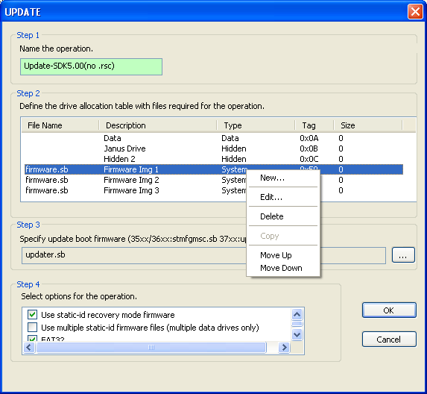

Figure 6

Step 1 – Name the operation
This field is used as a folder name under the profile Folder and
contains any files required by the operation. The operation folder
must conform to Windows® file-naming conventions. The application
does not support multiple operations of the same name in a given
profile.

Step 2 – Define the drive allocation table and firmware files
This operation is highly dependent on the configuration of firmware
downloaded to the device. The drive allocation table must match
that of the firmware.

Using the provided example profiles as a guide for a particular base
SDK, add drives to the table to match those expected by firmware.

Right click the mouse in the drive list control to display the context
menu options.

New – Create a new drive. Opens the Drive Edit dialog to allow the
user to specify the details of the new drive.
Edit – Edit the existing drive. Opens the Drive Edit dialog to allow
the user to change details of the existing drive.
Delete – Deletes the drive form the table. Any associated file is also
removed from the operation folder.
Copy – If another drive of this type is available, use this option to
automatically create the next available drive of this type.
Move Up – Moves the drive up in the table.
Move Down – Moves the drive down in the table.

The Drive Edit dialog below specifies the details of a drive. The drive
tag is selected automatically based on existing tags for that type
already defined in the table.

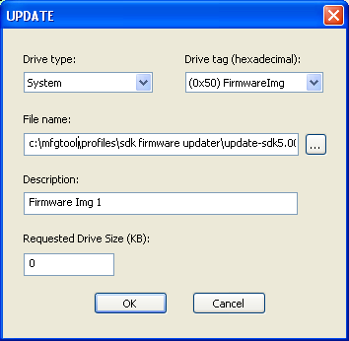

Figure 7

Step 3 – Specify the update boot firmware
The application downloads and boots a firmware image to perform
the update. Normally, this is stmfgmsc.sb (35xx/36xx), or updater.sb
(37xx). Browse to the file, or drag+drop the file into the edit control.

Step 4 – Select update options
Select the available options for the UPDATE operation.

Static-id recovery mode firmware – Enabling this option will allow
the update operation use the Static-ID firmware to eliminate unique
enumeration of each device.
It is strongly recommended that static-ID firmware be created and
this option enabled.
Use multiple Static-id firmware files – A device with more than one
data drive must report a serial number. Enabling this option will
cause the application to look for static-id firmware files named
stmfgmsc1.sb, stmfgmsc2.sb, stmfgmsc3.sb, and stmfgmsc4.sb. Each
file should report a unique serial number. This will prevent windows
from enumerating the drives more than once per panel.
FAT32 – Enabling this option will force the update operation to
format the media using FAT32. If this option is not enabled, the
update operation will decide on the type of FAT to use based on the
size of the media. If the media size is less than 2GB, FAT16 will be
used. For media sizes greater than 2GB, FAT32 will be used.

Windows CE – Select this option for STMP devices running the
Windows® CE operating system.

COPY Operation

This operation is used to pre-load content to the device media after updating. Content can contain a directory hierarchy with subfolders. The content window in the dialog much as an explorer window with folders on the left side and files in the selected folder on the right.

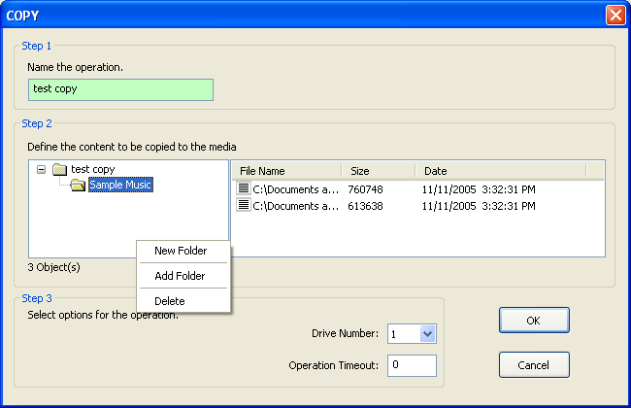

Figure 8

Step 1 – Name the operation
This field is used as a folder name under the profile Folder and
contains any files required by the operation. The operation folder
must conform to Windows® file-naming conventions. The application
does not support multiple operations of the same name in a given
profile.

Step 2 – Select files for the operation
Use the right click context menus to add folders to the left side or
add files to the selected folder on the right side. The controls
support drag+drop of folders and files.

The easiest and most consistent way to add content is to create a
location containing the content to be copied to the media in the
hierarchy desired on the media, and then simply drag+drop the folder
into the window.

Step 3 – Select options for the operation
Drive Number – Normally there is only one data drive; however, some
players define more than one. Use this field to select the destination
data drive.
Operation Timeout – Specify how many minutes to wait for the
operation to complete. Zero is no timeout, or infinite.

LOAD Operation

The load operation loads the specified custom firmware application .sb file to the HID device and waits for the player to come up in MTP mode before entering the “Complete” stage.

*This is operation is not available for STMP 35/36XX devices.

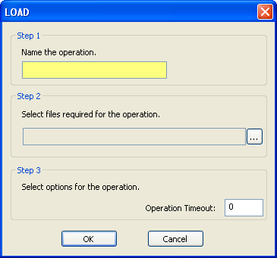

Figure 9

Step 1 - Name the operation
This field is used as a folder name under the profile Folder and
contains any files required by the operation. The operation folder
must conform to Windows® file-naming conventions. The application
does not support multiple operations of the same name in a given
profile.

Step 2 – Specify the custom firmware application
Use the button to the right of the file name edit control to open the
Open File dialog, or drag+drop a file from explorer into the control.

Step 3 - Specify options for the operation
Operation Timeout – Specify how many minutes to wait for the
operation to complete. Zero is no timeout, or infinite.

OTP Operation

The OTP operation is used to write values into the OTP (One-time
programmable) registers in the device. The operation writes a user
defined value into the first available OTP register. For further
information about how to use the OTP registers see the document
Programming OTP Bits and Encrypting Firmware in the STMP37xx.

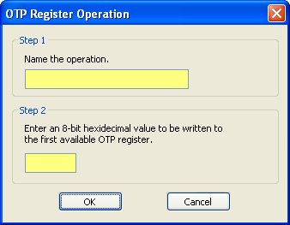

Figure 10

Step 1 – Name the operation
This field is used as a folder name under the profile Folder and
contains any files required by the operation. The operation folder
must conform to Windows® file-naming conventions. The application
does not support multiple operations of the same name in a given
profile.

Step 2 – Enter the value to be written
Enter a 8-bit hexadecimal value. This will be written to the first
available OTP register.

USB Ports (tab)
Within the USB Ports tab, a visual representation of all the USB ports on the system is displayed. When any USB device is attached to the computer, the device description will appear next to the port node, and it will indicate Connected.
Up to sixteen (16) physical ports can be assigned for use during the manufacturing process. Use the Maximum USB Ports control in the lower left portion of the window to define the maximum number of USB ports to be used.
While selecting ports, after the maximum defined ports are selected, the rest of the checkboxes will gray out indicating that no more ports are available. The Panels are assigned in alphabetical order. Given that all Panels are unassigned, the first USB port checked will be assigned to Panel A, the second port checked will be assigned to Panel B, etc. If some Panels are already assigned, the next checked port will be assigned to the first available Panel alphabetically.
Select the physical ports that are to be used during the manufacturing process. When a port is selected, the name of the associated (assigned) Panel will appear next to the port node. The operation panels (A, B, C, and D) in the main application window correspond to the four physically assigned ports (see Figure 11).
Do not add or remove USB hubs from the system once the Operations Panels are assigned to USB ports.
It is recommended that the user label each of the physical hub ports with the corresponding Panel letter to facilitate the cycling of devices though the process.
The Start button in the main application window will not be enabled unless at least one USB port is assigned to a panel.

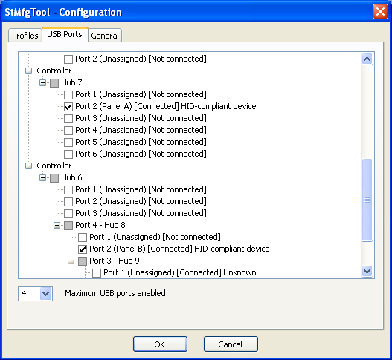
Figure 11

General (tab)
General preferences are set in the General tab (see Figure 12).
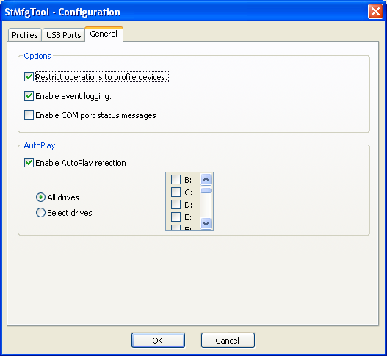
Figure 12

Options

Restrict operations to profile devices – This option is used by all operations. When checked, operations will only run on devices that have USB VID/PID matching the IDs in the profile. Thus, the Freescale MSCN device can not be updated if the Freescale Semiconductor MSCNMMC Audio Player profile is selected; unless the MSCN device is placed into recovery mode, at which point it becomes a Player Recovery Device and not a Freescale emiconductor MSCN device. When this option is unchecked, any STMP 35xx/36xx based device can be operated on independent of the profile selected. The Restrict operations option is checked by default.

Enable event logging – When checked the application will generate a file named stmfgtool.log in the application install directory. A timestamp will be entered into the file each time the Start button in the main application is pressed. After the timestamp the event logger will record information about the device at the end of each operation. This file does not get deleted between instances of the application, and new data is always appended to the end of the file. This option is enabled by default.

Enable COM port status messages – When checked each Operation Panel will write status messages to an associated COM port. This option can be used in conjunction with an external tool watching the COM ports to monitor operation status. This is normally used in manufacturing automation.

The status messages are written to the COM ports at the beginning and end of operations for each device. The messages are text and include:

“ST” – Operations started

“OK” – Operations completed successfully

“NG” – Operations failed

The COM port associated with an Operation Panel is defined by the panel number. For example, Panel A will open COM1, Panel B will open COM2, and so on.

AutoPlay

Select the Enable AutoPlay rejection checkbox to prevent Windows® OS from automatically opening an Explorer window every time a new device is installed (enumerated) on the computer, which may cause manufacturing delays. To select all drives, choose the All drives option. If only specific drives are to be prevented from opening Explorer windows, choose Select drives, and select the desired drive letter(s). AutoPlay rejection for all drives is enabled by default. To disable AutoPlay rejection, uncheck the Enable AutoPlay rejection checkbox. AutoPlay rejection is enabled for all drives by default.

Initializing the system

There are three final configuration procedures that must be performed before the application is ready for continuous operation. Section 6.1 describes how to pre-load the Recovery-Mode drivers for STMP 35/36XX devices onto each of the USB ports used by the Manufacturing Application. Section 6.2 describes how to pre-load the Static-ID USB Mass Storage drivers onto each of the same USB ports. The final initialization step is described in Section 6.3.

To prepare for these steps, launch the Manufacturing Application. Ensure that it is fully configured and in monitoring mode.

Step 1 - Pre-Loading the Recovery Mode Driver (STMP 35/36XX)
This section is relevant to STMP 35/36XX devices only.
Each physical USB port that will be used with the manufacturing application must be loaded with the Recovery Mode Driver. The Recovery Mode Driver allows the PC to communicate with the device while in Recovery Mode. This procedure only has to be done once for each port.
The Recovery Mode Driver is installed automatically by the Manufacturing Application.
To load the Recovery Mode Driver for each port:
- Plug the device into the external USB hub port that is to be configured.
- Place the device in Recovery Mode.
- The PC will recognize a new device is attached and attempt to load the Recovery Mode Driver.
- Repeat Steps 1-6 for each physical port that is to be used with the manufacturing application (up to 16).
If the system is asking for a reboot, answer No at this time. The system will be rebooted after completing the procedure in the next section.

Step 2 - Pre-Loading the Static-ID USB Mass Storage Driver
[If the Static-ID Firmware is not being used, skip this section.]
Each physical USB port that will be used with the Manufacturing Application must be loaded with the Static-ID USB Mass Storage Driver. The USB Mass Storage Driver allows the PC to communicate with the device while in USBMSC Mode. This procedure only has to be done once. For STMP 35/36XX devices the steps outlined in Section 6.1 must be completed before starting this procedure.
To load the Static-ID USB Mass Storage Driver for each port:
- Ensure that an UPDATE operation is enabled in the Player Profile, and that the Use static-id recovery-mode firmware option (see Error: Reference source not found) is enabled for the operation.
- Disconnect and reconnect the four devices (in recovery-mode) to ensure the devices are ready (see Error: Reference source not found).
- Click Start in the main application window.
- The Static-ID firmware will be loaded into the four devices, and the system will enumerate them as USB Mass Storage devices and assign each of the devices a drive letter. Be sure to have enough available drive letters for the number of ports enabled, and that the drive letters are consecutive with no other device drives between the starting and ending drive letters.
- Allow all Operation Panels to run to completion (see Figure 1). If the system displays a reboot dialog (see Figure 2), answer No if the Manufacturing Application does not look like Figure 1. Alternatively, leave the reboot dialog open, complete the steps in this procedure, and click Yes to initiate Step 3.
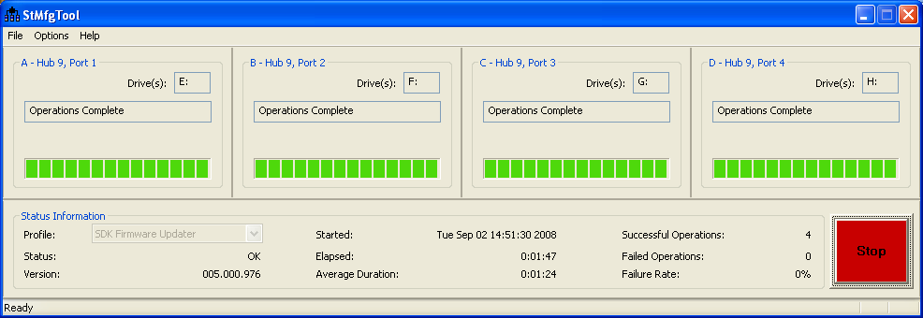
Figure 1

- Click Stop and disconnect the STMP devices.
- Click Exit to close the application.

Step 3 - Reboot the System
If the operating system requested a reboot, this step is critical and must be done to ensure system stability during continuous operation of the Manufacturing Application.

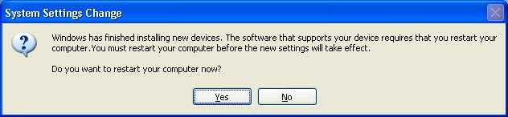
Figure 2

Running the Application

Having completed all of the preceding setup, configuration, and initialization procedures, the application is now ready for mass production of STMP based devices.
- Launch the application.
- Select the Player Profile appropriate for the hardware.
- Ensure the USB ports are assigned to the Operation Panels and that each port has been initialized.
- Click the Start button.
- Attach STMP based devices to the assigned USB ports.
- Operations for the attached device will begin automatically.
- When the device is complete, replace it with the next device.
- If an error occurs, remove the device and replace it with a new device.
- Continue in this manner until all the devices have been processed.

Registry Scrub

When the Manufacturing application is started, it does a brief search through the Windows® registry for device entries matching the profiles. If there are an excessive number of device entries found, the application suggests cleaning the registry for improved performance and reliability.

To launch the registry scrub utility, on the main application window, select menu item Options→Clean Registry. If the current profile is invalid, an error message will be displayed instructing the user to select a valid profile before allowing access to the Registry Scrub dialog. If the current profile is valid, pertinent profile information will be reflected in the Registry Scrub dialog. (See Figure 3.)

Registry Scrub is a functional utility designed to assist in the removal of STMP based USB Mass Storage device information from the Windows® registry. Each time a USB Mass Storage device is initially connected to the PC, the OS enumerates the device and create three to five unique registry device node entries. The number of device node entries depends on the number of drives allocated to the USB Mass Storage device. These unique registry entries allow the system to ‘remember’ what type of device is being connected to the system and which drivers to load the next time the device is connected to the system (expedites the connectivity process).

Every USB device generates a unique set of device node entries in the system registry. If the same USB device is connected to a different USB port, another unique set of device node entries are created. If a new USB device(B), different from the USB device(A) by only the device serial number, is connected to the same USB port where device(A) was connected, another set of device node entries are created. This type of operation is normal and useful in an end-user environment, but can drastically affect system performance in a manufacturing environment.

The Use static-id recovery-mode firmware for UPDATE operations (see Error: Reference source not found) was designed to reduce registry build-up and device enumeration time by not reporting the device serial number to the OS. By using the static-id firmware, all of the manufacturing devices will appear identical to the OS. After the initial enumeration (during the setup/configuration phase of this application) the OS will not need to enumerate future devices.

Down-stream PCs used to test the device after it has booted from the internal media will be affected by unique serial number reporting, and will eventually have many device node entries in the system registry. Run the Registry Scrub operation periodically on manufacturing test PCs that incur unique serial number registry build-up to maintain optimal system performance.

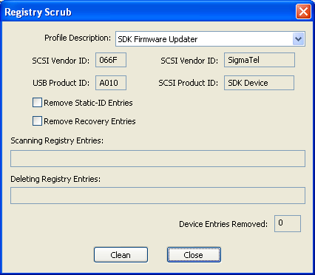
Figure 3

Profile Description (drop-down list)
The active profile is selected by default. The user can change the profile selection by clicking on the Profile Description pull down menu and selecting the desired profile from the available list. Once selected the USB and SCSI fields will display the Vender and Product IDs.

Clean (button)
Initiates the Windows® registry cleaning process. The currently selected profile must be valid to begin cleaning the registry. Once the Clean button is pressed, the application examines three device enumeration categories: Enum\USB, Enum\USBSTOR, and Enum\Storage and removes device entries matching the selected profile’s criteria. Progress is indicated in the status fields: Scanning Registry Entries and Deleting Registry Entries. These status fields display Finished when the registry cleaning process is complete. The number of device nodes removed is displayed at the bottom of the dialog.
It is recommended that all devices matching the current profile be disconnected from the PC before starting the registry clean process.

Close (button)
Closes the Registry Scrub dialog.

Remove Static-ID Entries (checkbox)
This check box allows the user to remove the non-serialized device node entries in addition to device entries matching the selected profile’s criteria.
This option is for advanced troubleshooting and should not be checked during normal registry maintenance. Removal of non-serialized device node entries will require the user to completely go through the application’s setup/configuration reboot process.
Only check this box if experiencing problems with the static-id firmware files.

APPENDIX

Troubleshooting
The STMP Manufacturing Application is a complex, system-dependent program. Assumptions regarding logical operation-linking and device states were made to create the continuous-operation environment. Every effort has been made to ensure the stability of this application.
Explicitly following all of the procedures outlined in this document is the best way to avoid most problems.
The following sections may provide some insight if a problem does arise.
- Why do I get ‘Invalid Device’ and a RED progress bar?
Cause: | Solution:
The attached device is not a STMP device. | Disconnect the non-STMP device, or assign a different USB port to the operation panel.
The attached device is in USBMSC mode, the devices IDs do not match the current profile, and Restrict operations to profile devices is checked. | Place the STMP device in recovery mode, or uncheck Restrict operations to profile devices.
- Why does the status hang at ‘Waiting for device’ even though the device is connected to the USB port?
Cause: | Solution:
The attached device is not connected to the panel’s assigned USB port. | Ensure that the USB port the device is connect to is assigned to the ‘hung’ panel.
The attached device is a STMP device that ‘timed-out’ in recovery-mode. | Disconnect the device and re-connect it in recovery-mode.
The attached device is not connected to an external USB 2.0 hub. | Some PCs have multiple controllers for a single USB port. The device will enumerate on one controller or the other depending on the type of device (USB 1.1 or USB 2.0). The STMP 35xx/36xx is a USB 1.1 device in recovery-mode and a USB 2.0 device in USBMSC-mode. Connecting the device to an external USB 2.0 hub allows the device to enumerate on the same controller/port in both modes.
Device may be defective. | Re-connect the device in recovery-mode for a second pass. If there is still a problem, analyze the device for hardware defects.

- Why does the same drive letter appear in 2 panels at the same time?
Cause: | Solution:
The system is in an unstable state. | Use the registry scrub utility to clean the mass-storage device entries. Ensure the Remove static-id entries box is checked. Re-initialize the manufacturing ports (see Step 2 - Pre-Loading the Static-ID USB Mass Storage Driver).
Device may be defective. | Re-connect the device in recovery-mode for a second pass. If there is still a problem, analyze the device for hardware defects.
- Why does the application not stop when I click the Stop button?
Cause: | Solution:
An operation is still in progress. | Wait for the operation to complete. Some operations on large media can take significant amount of time to complete.
Device may be defective. | Re-connect the device in recovery-mode for a second pass. If there is still a problem, analyze the device for hardware defects.
- How did my Panel become Unassigned?
Cause: | Solution:
The USB device-tree changed. The assigned port was on a hub that was disconnected from the system. | Reassign a USB port to the panel and repeat the initialization processes.
- What do I do with a device that does not get to Operations Complete status?
Cause: | Solution:
Device may be defective. | Re-connect the device in recovery-mode for a second pass. If there is still a problem, analyze the device for hardware defects.

Error Codes
The Manufacturing Application uses standard Windows® defined system error codes. The table below lists some of these errors that may typically be seen. They can assist in debug or in error reporting back to Freescale Semiconductor.

Code | Meaning
0 | ERROR_SUCCESS  The operation was successful.
0x2 | ERROR_FILE_NOT_FOUND  The application was unable to find the specified file.
0x79 | ERROR_SEM_TIMEOUT  The operation has met the timeout period. This is the usual result when a device has become unresponsive.
0x42B | ERROR_PROCESS_ABORTED  The operation was aborted by the user.
0x139F | ERROR_INVALID_STATE  The device is not in the expected state. This results when the application resets the device to boot in MSC mode, but the device boots into recovery mode instead due to some failure to boot the downloaded firmware.

